# Lab: Linux and Linux Shell

Lab for the "Containers and Clouds" course @ SoftUni

## Configure Connectivity of the VM

The first step is to open the link – <https://labs.play-with-docker.com/>. 

Then press the **[Login]** button and click on "**docker**". A new dialog box opens, which is for **docker registration**. If you don't have a registration click on **[Sign Up]**. You have to create an account with a username, password and email. Then sign in to your account. It takes you to a page to select the plan you want – click on "**Continue to Free**" (Personal plan). Log in to the email you registered with and **confirm your account**. You may need to reload the page until you see this:



Click on the **[Start]** button.

Картина, която съдържа текст

Описанието е генерирано автоматично

You should see this. Click on **[+ add new instance]**.

Картина, която съдържа текст

Описанието е генерирано автоматично

We are ready for work!

## Getting to Know the Console

**Let's start writing the command in the docker playground.**

On the prompt, we can **input the user and password** that we created during the installation. Of course, we can use the **root** **user**, but it is not considered a good practice.

Now, let’s check where (in which **folder**) **we are** with the pwd command:

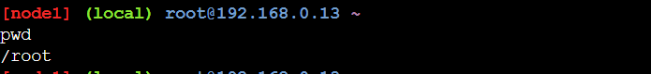

It appears that we are in our **home folder** (/home/lsauser).

Check what we have here:



There is **nothing** or at least it appears to be this way. Of course, what we will see here on a **clean new installation** depends on what **distribution we chose** and **what settings** there are by default.

Even though we are not familiar with all options on the ls command yet, let's check if there are **any hidden files and** **folders** with:

Картина, която съдържа текст

Описанието е генерирано автоматично

Note that you can **autocomplete commands** by clicking the [Tab] **button** **twice** (Tab-Tab).

So, **there are some files** after all. Those are considered **hidden files**, because their name starts with the dot **symbol** (.). The same rule applies to **folders** as well.

Now, let's execute this:

Картина, която съдържа текст, телевизия, екран, тъмен

Описанието е генерирано автоматично

We can also **give arguments**, not only options. For example, we can check what we have in the **main** (**root**) **folder**. The "/"symbol is used to state that we want to **access the root of our file system**:

Картина, която съдържа текст

Описанието е генерирано автоматично

Картина, която съдържа текст

Описанието е генерирано автоматично

We can note that there is a **folder** named "**/root**". This is the **home folder for the root user**.

Let's **change the folder**. For example, go to the "/etc" **folder**. This is the place where most of the **configuration files** **are stored**. Then we can check if indeed we **changed the folder**:

Картина, която съдържа текст

Описанието е генерирано автоматично

As we can see, there is **no need** to execute pwd. The **prompt reflects or shows** where in the **file system tree** we are currently.

When we want to **address all files** **which name starts with something**, no matter what, and how many symbols their name contains, we can use the "*" symbol. For example, ask for **all files** starting with "os*":

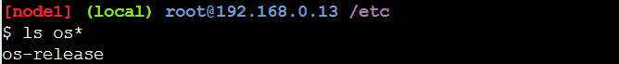

Okay, now that we know that this **file exists**, let's check **what it contains** (the actual output may be different):

Картина, която съдържа текст

Описанието е генерирано автоматично

It appears, that this **file** contains **detailed information** **about our** **distribution**.

**Similar or additional information** about the distribution we can get by executing:



Beside the information about the kernel, we can extract information about the **name of the host**:

Картина, която съдържа текст

Описанието е генерирано автоматично

Now, let's **return to our home folder**:

Картина, която съдържа текст

Описанието е генерирано автоматично

As we can see, if we execute the cd command **without any arguments**, the result is that we are "**back home**". There is also a **special symbol** that we can use – it is again the tilde symbol – "~".

Now, let's try a different approach. In general, no matter what distribution we use, there is a **common set of** **commands** that is always available.

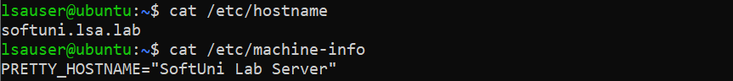

In order the **changes to be reflected in the prompt**, we must **close the session**, and **open a new one**. So, type logout and **log back in**:

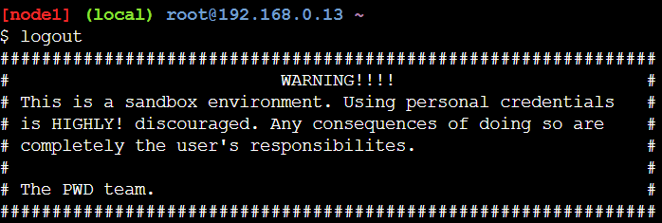

We can see that the **new name is applied**.

Now, we can check **what** **date is today** and **what is the time** **now**:

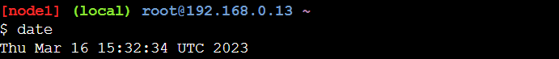

There is a way to **modify the output** of the date command:

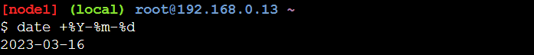

This way, we will receive the **current date**, represented in "YYYY-MM-DD" format.

Should we need a **calendar** on the command line, we can have it easily with:

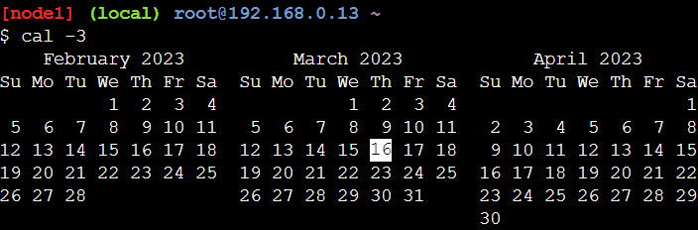

If we need to know **since when or how long our system is operating**, we can do it with:



At any point we can ask for the **history of executed commands**:

Картина, която съдържа текст

Описанието е генерирано автоматично

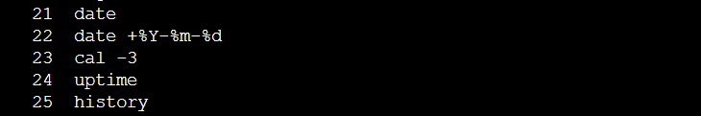

If we want to **end our session**, we can do it with either exit or logout. Issuing any of these will close our session but will leave the machine up and running. Let's type exit and press the [Enter] key. Our **session is closed** now:

Картина, която съдържа текст

Описанието е генерирано автоматично

Now **log in back again** and **ask for all files** (including hidden ones) in our **home folder**:

Картина, която съдържа текст

Описанието е генерирано автоматично

It appears that there is a **special file** that takes care for our **history** – .bash_history. Let's check its **contents**:

Картина, която съдържа текст

Описанието е генерирано автоматично

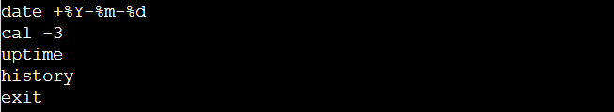

As we can see the **last few commands are not here** and there is a perfect explanation for this. The reason is that they are **kept in a buffer** and are stored on the disk only when certain events occur, like session end.